Here is a pattern I made with some graphs of trigonometric functions.
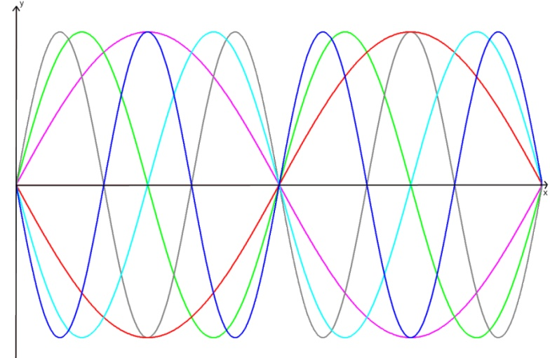
- The purple line is the graph y = sin x . Can you identify the coordinates of the points where it crosses the axes and where it reaches its maximum and its minimum values?
- How could I make the red graph from the purple graph? Can you work out the equation of the red graph?
- The green graph has equation y = sin 2x . Can you describe how to make the green graph from the purple graph? How does the transformation of the graph relate to the way the equation has changed?
- Using these ideas, can you work out the equations of the other graphs I have drawn?
Imagine you had a graphical calculator but the sine button is broken. Can you draw the same patterns using the cosine function instead? Explain how you can transform a cosine graph into a sine graph.

